**CASE STUDY-4**

**Problem Statement:** Client wants to provision an AWS S3 to provide **shared storage** across 3 AWS EC2 instances. The EC2 instances must exist in the same VPC with each instance in separate availability zone. Implement a solution to ensure that all the 3 EC2 instances can **mount the S3 bucket**. All these EC2 instances have **docker installed** on it. Use appropriate IaC (Infrastructure as code) tool to develop AWS infrastructure.

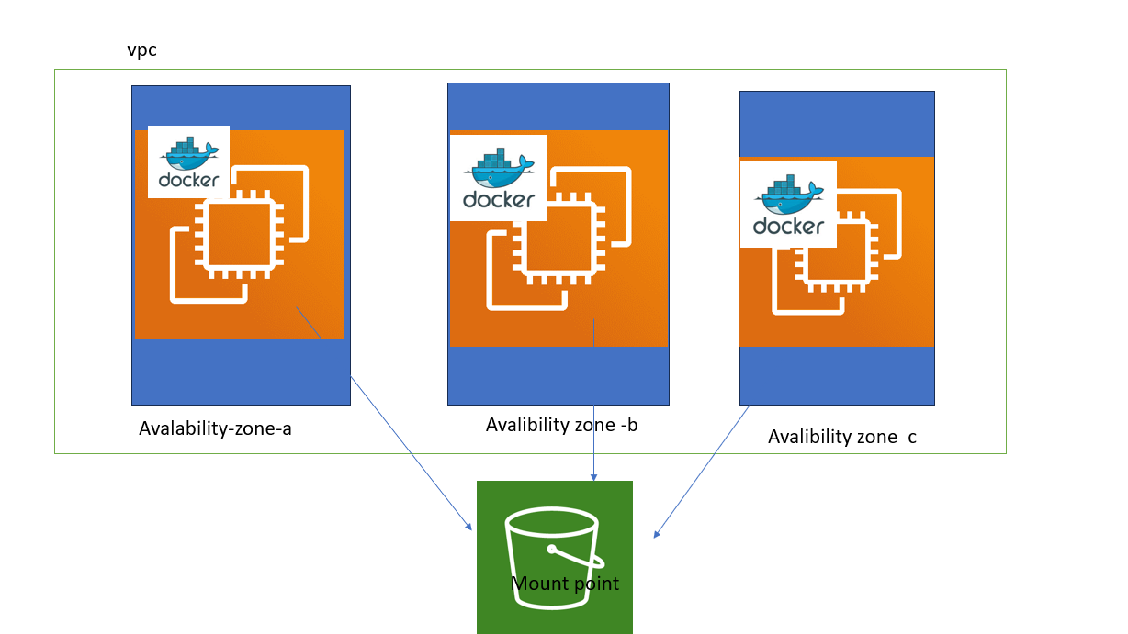

* **Create a VPC** with appropriate subnets and routing to ensure the EC2 instances can communicate.

* **Provision 3 EC2 instances** in different availability zones within the same VPC.

* **Create an S3 bucket** for shared storage.

* **Configure IAM roles and policies** to allow EC2 instances to access the S3 bucket.

* **Install and configure S3FS or AWS CLI on EC2 instances** to mount the S3 bucket.

Step by step procedure

**Create a VPC** with appropriate subnets and routing to ensure the EC2 instances can communicate.

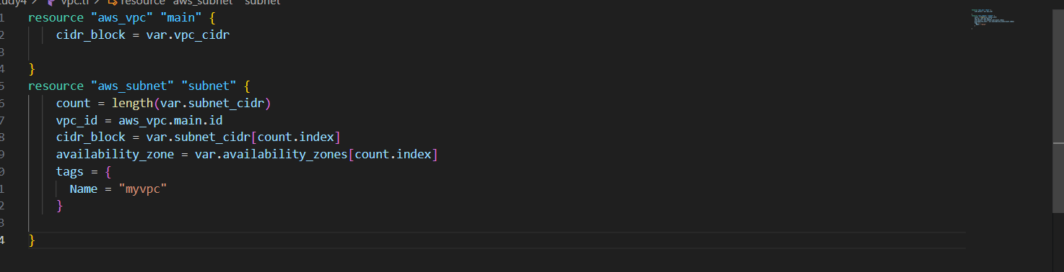

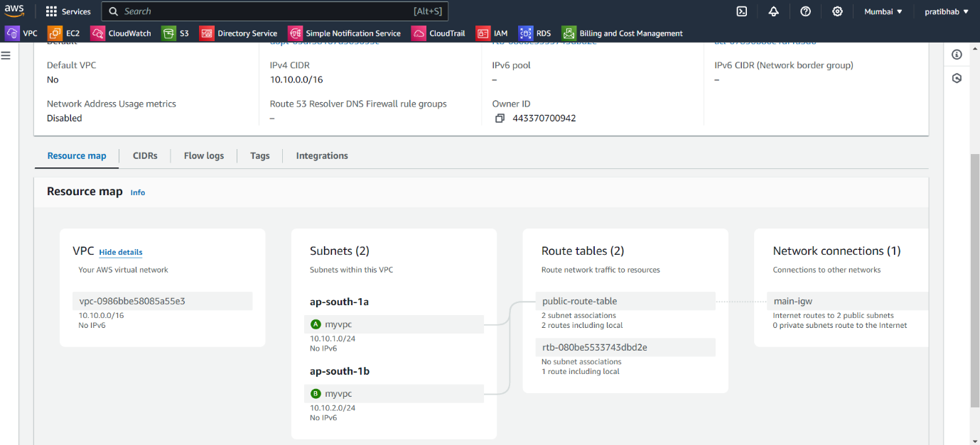

**2. Provision EC2 Instances**

Provision 3 EC2 instances in different subnets (availability zones).

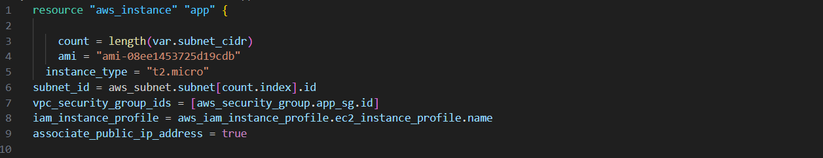

3. **Create an S3 Bucket**

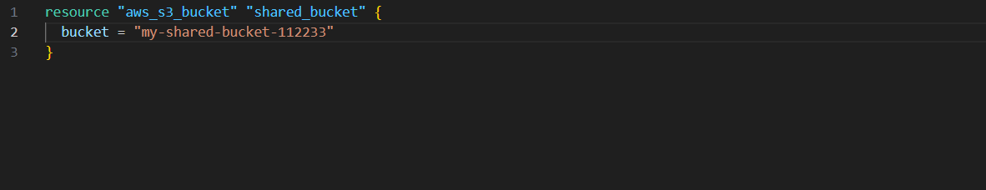

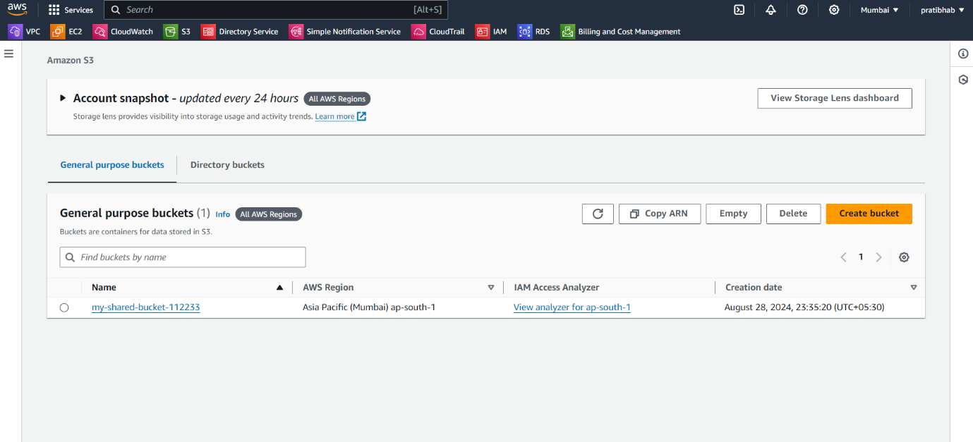

**4. Configure IAM Roles and Policies**

Create an IAM role and policy that allows EC2 instances to access the S3 bucket.

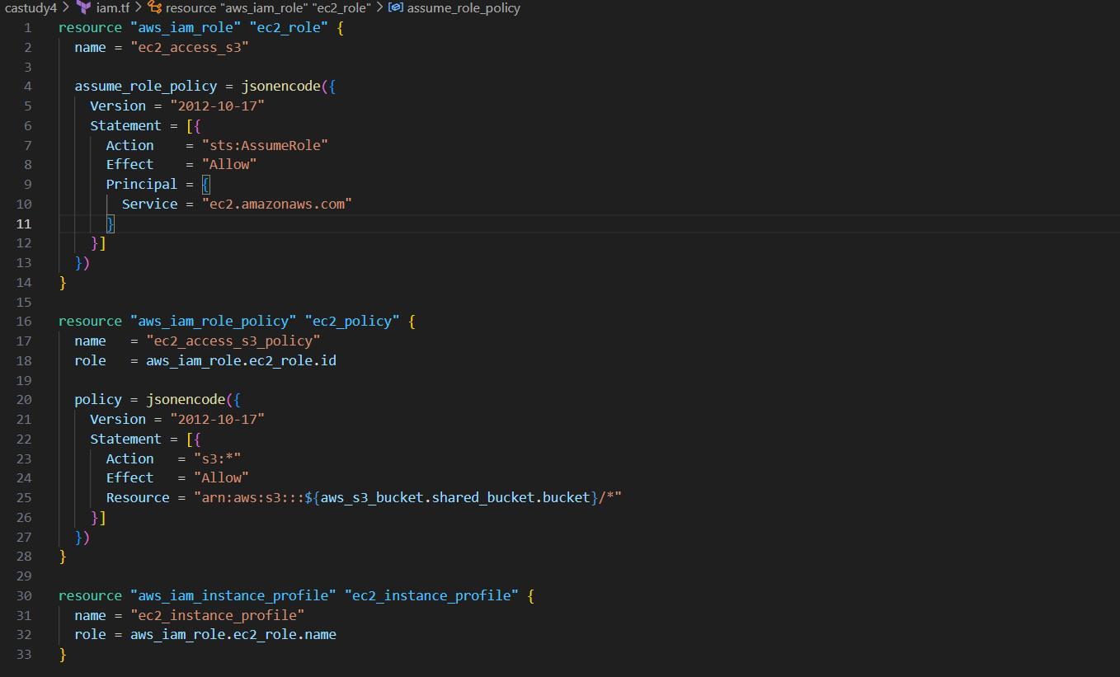

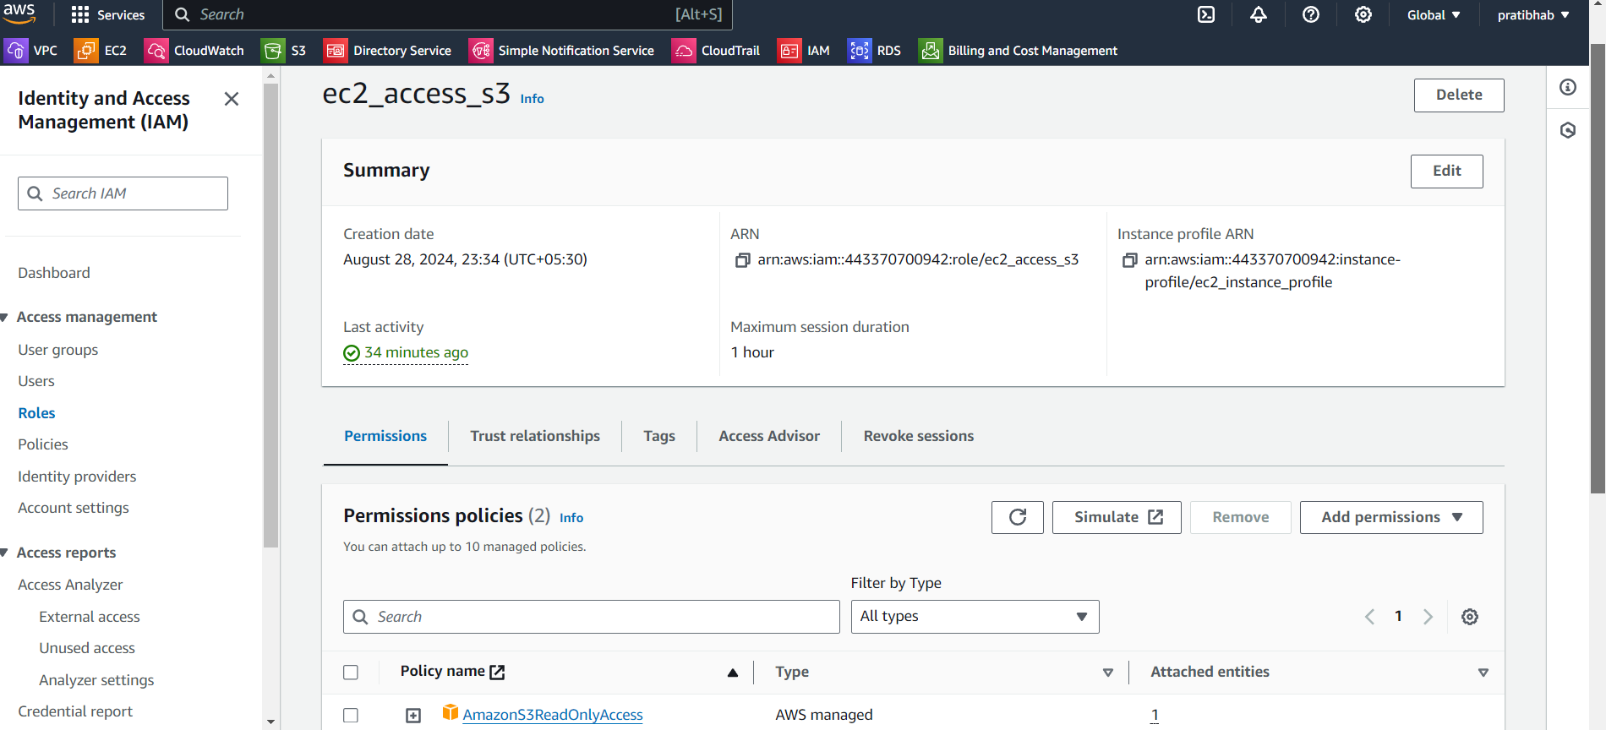

5. **Attach IAM Role to EC2 Instances**

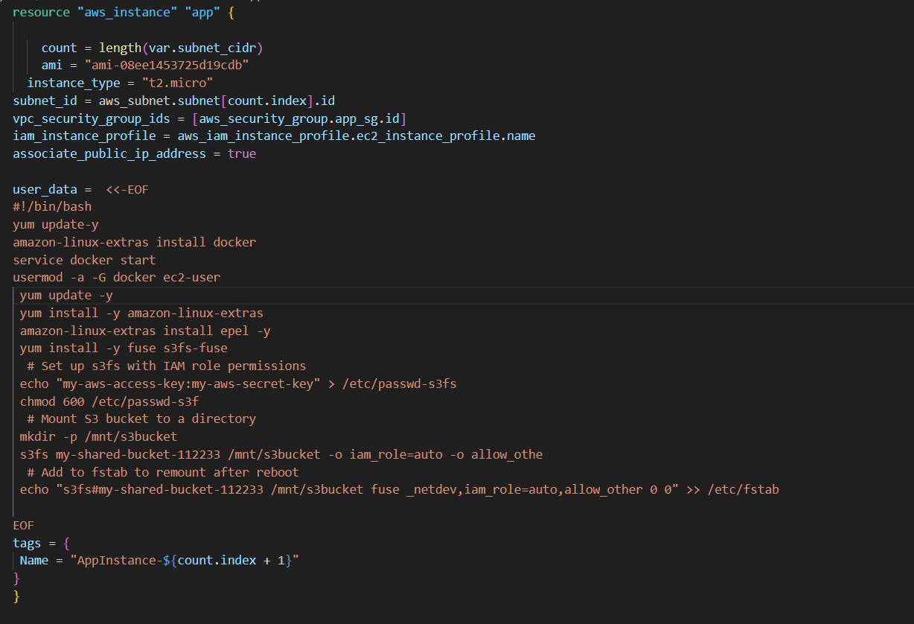

Check docker installed on EC2 instance and S3 (/mnt/S3bucket )mounting point

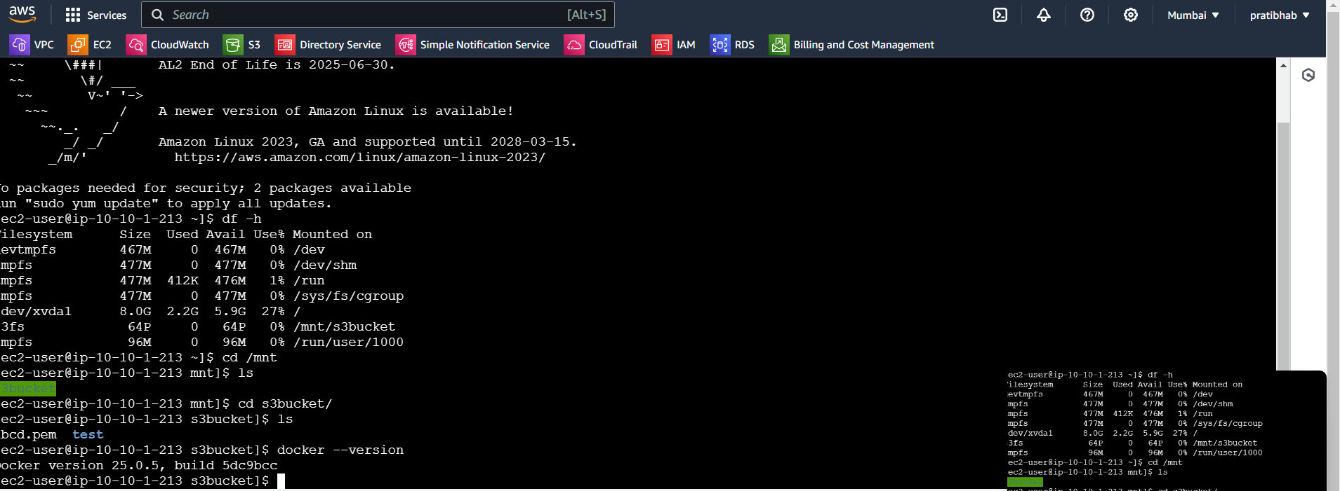

After writing of script run the command

Terraform init

Teraaform plan

Terrafrom validate

Terraform apply --auto-approve

GITHUB repository for script: <https://github.com/Pratibha251093/case-study-4.git>